**Report on - Capacitance Solver**

**By - Manoranjan Sahoo**

**Date: 25/01/2017**

Matlab:

|  |  |  |
| --- | --- | --- |
| Patch List Size | Time in Second | Memory |
| 8 X 8 | **.08382** |  |
| 18 X 18 | **.21738** |  |
| 32 X 32 | **.599717** |  |
| 50 X 50 | **1.396751** |  |
| 200 X 200 | **13.680172** |  |
| 450 X 450 | **46.041866** |  |
| 800 X 800 | **101.230112** |  |
| 1250 X 1250 | **177.416** |  |
| 1744 X 1744 | **365.27** | 369MB |
| 1800 X 1800 | **285.563** |  |
| 2450 X 2450 | **426.4788** |  |
| 3200 X 3200 | **611.176** |  |
| 4050 X 4050 | **814.357** |  |
| 5000 X 5000 | **1072.5112** |  |

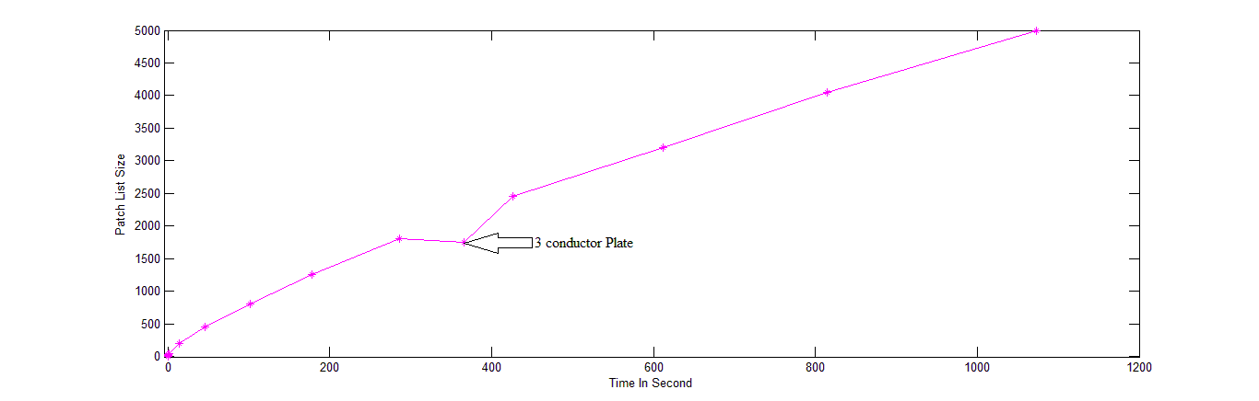

Visual Studio C++:

|  |  |  |  |  |  |  |  |  |  |
| --- | --- | --- | --- | --- | --- | --- | --- | --- | --- |
| Patch List Size | Total Execution Time | MOM fillerTime Release Mode | Expo  MOM | Const.  MOM(K) | Setup time O(n3) LU | Expo  LU setup | Constant LU(L) | Solve time O(n2) LU | CPU Memory Release Mode |
| 800 X 800 | 1.229 | 1.188 |  |  | --- |  |  | --- | --- |
| 1250 X 1250 | 2.751 | 2.631 | 1.78 | 1.776e-5 | 0.074 | 2.91 | 2.63e-10 | --- | 16.02MB |
| 1744 X 1744 | 5.406 | 5.234 | 1.84 | 3.9463-4 | .191 | 3.023 | 3.03e-11 | 0.004 | 28.6MB |
| 1800 X 1800 | 5.212 | 5.061 | 1.97 | 1.99e-6 | .201 | 2.912 | 6.66e-11 | 0.002 | 30.2MB |
| 2450 X 2450 | 9.299 | 9.001 | 1.98 | 1.752e-6 | .555 | 2.95 | 5.5e-11 | 0.005 | 53.3MB |
| 3200 X 3200 | 15.745 | 15.688 | 2.02 | 1.303e-6 | 1.115 | 3.01 | 3.13e-11 | 0.007 | 87.4MB |
| 4050 X 4050 | 25.646 | 24.86 | 2.08 | 7.79e-7 | 2.192 | 3.1 | 1.43e-11 | 0.011 | 136.7MB |
| 5000 X 5000 | 43.544 | 40.941 | 2.13 | 5.4e-7 | 4.064 | 3.12 | 1.16e-11 | 0.016 | 204.7MB |
| 9800X9800 | 168.483 | 154.211 | 2.21 | 2.33e-7 | 30.046 | 3.01 | 2.91e-11 | 0.081 | 759.4MB |
| 20kX20k | 498.3 | 496 | 2.17 | 2.24e-7 | 247 | 2.97 | 2.9e-11 | 0.413 | 3104.4MB |
| 27kX27K | 1594.96 | 1588.17 |  |  | 1131 |  |  |  |  |

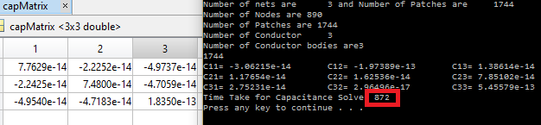My first cap o/p in c++:

Time (MOMfill) = K*(Np)^(exp1)

Time (LU setup) = L*(Np)^(exp2)

Solving above equation

K = (17 - .2)*e-6, exp1 = (1.78-2.12).

L = (26-1)*e-11, exp2 = (2.91-3.12)

Let’s assume K =2e-5, L = 2e-11, exp1=2, exp2=3

So 2 curves will intersect at a patch Size of (100k).

SO for 100k RAM = 100X100Xe6X8=100GB (Results are shown upto 27k*27k*8(5.8GB) as Ram is only *8GB)



***Log-log plot between Number of patches (Unknowns) and time.***

***(Previous one which I had shown in Group meeting)***

|  |  |  |  |  |  |  |
| --- | --- | --- | --- | --- | --- | --- |
| Patch List Size | MOM fillerTime Release Mode | Expo  MOM | MOM  Const(K) | Setup time O(n3) LU | LU Const(L) | Expo  LU setup |
| 800 X 800 | .739 |  |  | --- |  |  |
| 1250 X 1250 | 1.515 | 1.61 | 1.5e-5 | 0.074 | 2.63e-10 | 2.91 |
| 1744 X 1744 | 2.91 | -- |  | .191 |  | 3.023 |
| 1800 X 1800 | 2.766 | 1.65 | 1.17e-5 | .201 | 6.66e-11 | 2.912 |
| 2450 X 2450 | 4.633 | 1.67 | 1.01e-5 | .501 | 5.5e-11 | 2.95 |
| 3200 X 3200 | 7.59 | 1.84 | 2.6e-6 | 1.115 | 3.13e-11 | 3.01 |
| 4050 X 4050 | 12.023 | 1.952 | 1.1e-6 | 2.192 | 1.43e-11 | 3.1 |
| 5000 X 5000 | 19.29 | 2.2436 | 9.7e-8 | 4.064 | 1.16e-11 | 3.12 |
| 9800X9800 | 88.03 | 2.201 | 1.44e-7 | 30.046 | 2.91e-11 | 3.01 |
| 1.28X1.28 | 167 | 2.39 | 2.5e-8 | 65 |  |  |
| 20kX20k | 496 | 2.42 | 1.9e-8 | 247 | 2.9e-11 | 2.97 |
| 27kX27K | 1588.17 | 3.87 | 3.4e-14 | 1131 | 3.03e-11 | 3.04 |
| 27kX27K | 1303 | 3.2184 | 7.7e-12 | 870 |  |  |
| 27KX27K | 1965 | >5 |  | 1462 |  |  |



***Log-log plot of number of patches and time taken in seconds.***



***Normal plot of number of patches and time taken in seconds.***